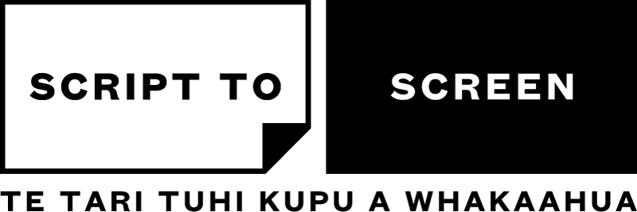
PAERANGI
VIDEO 2 – WHAT MAKES A GOOD STORY?

HOMEWORK
Jot down three different story ideas and write a paragraph on each
- Include a beginning, middle and end
- Who is the main character and what do they want?
- Dig into your creative instincts, think about what’s important to you, what you want to say, and have fun!
WATCH LIST
The Dump  Short film, 2012, 10’32’’  Writer/Director - Hamish Bennett  Producer - Orlando Stewart | The Feijoa Club  Web series, 6 x 8-11mins, 2020  Writer - Kerry Warkia, Keil McNaughton  Director - Kerry Warkia, Nicole Whippy  Producer - Kerry Warkia, Keil McNaughton
Hitch Hike  Short film, 2011, 11’38’’  Writer/Director - Matthew J Saville  Producer – Julia Parnell | ’Kura  Web series, 5 x 6-12mins, 2020  Writers - Vince McMillan, James Watson  Director - Vince McMillan  Producer – James Watson
I’m Going to Mum’s
Short film, 2012, 12’32’’
Writer/director - Lauren Jackson
Producer - Jeremy Macey

GLOSSARY
Mise-en-scène – a french term which literally translates to ‘placing on stage’. It is used as a catch-all phrase in both theatre and film when referring to everything placed on stage or in front of the camera that contributes to the overall look and feel of the production. This can include actors, blocking, location/setting, costume, makeup, production design, props and lighting.
Short – abbreviation for short film, which are typically narrative (scripted) films between 5 and 15 minutes long. Occassionally short films are as short as 1 minute, and as long as 45 minutes. Most film festivals have a limit of 15 minutes in length for short films, as this makes them easier to programme in a shorts selection. Some film festivals will screen films up to 45 mins long - this is much more common for documentary and very rare for narrative films.
Feature – abbreviation for feature film, which are full length films. The term can be used for narrative (scripted) films or documentaries (which you might see abbreviated to ‘feature docs’). The term feature implies the film is around 90 minutes in length, but features can be as short as 75mins and be anywhere up to 3 hours long, occasionally even longer.

